**Restaurant Management**

A Skill Oriented Course Web Application report

Submitted in the partial fulfillment of the requirements for

the award of the degree of

Bachelor of Technology

in

Computer Science and Engineering

by

**Gunde Neha 20761A0584**

Under the guidance of

Dr. K Devi Priya

Associate Professor, Dept. of CSE



**Department of Computer Science and Engineering**

**Lakireddy Bali Reddy College of Engineering (Autonomous)**

**Accredited by NAAC & NBA (Under Tier - I)**

**Affiliated to JNTUK, Kakinada; ISO 9001:2015 Certified**

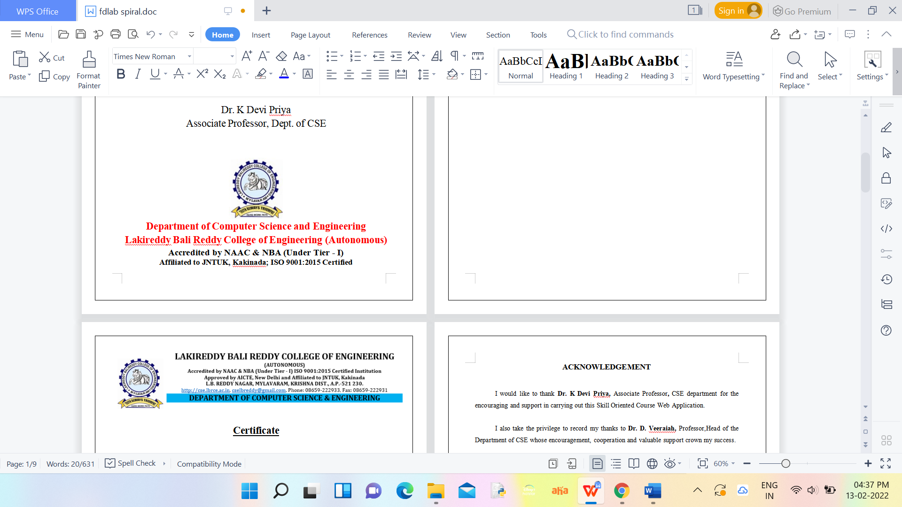

**Certificate**

This is to certify that the Skill Oriented Course Web Application / Project entitled “ Online **Restaurant Management**” is being submitted by **Gunde Neha** in partial fulfillment for the award of B. Techin Computer Science & Engineering to the Jawaharlal Nehru Technological University Kakinada is a record of bonafide work carried out by him/her under our guidance.

The results embodied in this Skill Oriented Course Web Application / Project report have not been submitted to any other University or Institute for the award of any degree or diploma.

**ACKNOWLEDGEMENT**

I would like to thank **Dr. K Devi Priya,** Associate Professor**,** CSE department for the encouraging and support in carrying out this Skill Oriented Course Web Application.

I also take the privilege to record my thanks to **Dr. D. Veeraiah,** Professor,Head of the Department of CSE whose encouragement, cooperation and valuable support crown my success.

I express my thanks to the support given by management in completing my Web Application / Project. I also express my sincere gratitude & deep sense of respect to the Principal, **Dr.K. Appa Rao** for making us available all the required assistance and his support and inspiration to carry out this Skill Oriented Course Web Application / Project in the Institute.

I am thankful to the teaching and non-teaching staff of CSE department for their direct as well as indirect help in my Skill Oriented Course Web Application / Project.

I am elated to avail my selves to this opportunity to express my deep sense of gratitude to my parents.

**ONLINE RESTAURANT MANAGEMENT**

**Abstract**

“Online Restaurant Management System” is a web application. This system is developed to automate day to day activity of a restaurant.Online Restaurant Management system for manage the restaurant business. So, this application is done for main purpose of online ordering…

**CONTENTS:**

**CONCEPTS Page No**

1. Introduction 1

2. Working 2

2.1 Importing modules /loging 2

2.2 Creating the display of game/Bank Tranactions

2.3 Assigning key direction 3

2.4 Creating gameplay 4

3. Modules/Technogies Used 3.1 HTML 7

3.2 CSS 7

3.3 Random module 9

4. Implementation 10

4.1 Coding 10

5.Results/Screens 14

6. Conclusion 16

7. References 17

**LIST OF IMAGES**

**CONCEPTS PageNo**

2.2.1 Window screen 3

5.1Initial screen 14

5.1 Game screen 14

5.1 Final screen

**2.MODULES/TECHNOLOGIES USED:**

**2.1 HTML**

**2.2 CSS**

**2.3 JAVASCRIPT**

**2.1 HTML**

HTML stands for Hyper Text Markup Language.

HTML is the standard markup language for creating Web pages.

HTML describes the structure of a Web page.

HTML consists of a series of elements.

HTML elements tell the browser how to display the content.

**HTML Headings:**

HTML headings are defined with the <h1> to <h6> tags.

<h1> defines the most important heading.

<h6> defines the least important heading.

EXAMPLE:

<h1>heading</h1>

**HTML Paragraphs:**

HTML paragraphs are defined with the <p> tag.

EXAMPLE:

<p>paragraph</p>

**HTML Links:**

HTML links are defined with the <a> tag:

EXAMPLE:

<a href="https://www.w3schools.com">This is a link</a>

**HTML Images:**

HTML images are defined with the <img> tag.

The source file (src), alternative text (alt), width, and height are provided as attributes:

EXAMPLE:

<img src="w3schools.jpg" alt="W3Schools.com" width="104" height="142">

**HTML Styles:**

The HTML style attribute is used to add styles to an element, such as color, font, size, and more**.**

Setting the style of an HTML element, can be done with the style attribute.

<tagname style="property:value;">

**Background Color:**The CSS background-color property defines the background color for an HTML element.

EXAMPLE:

<h1 style="background-color:powderblue;">This is a heading</h1>  
<p style="background-color:tomato;">This is a paragraph.</p>

HTML Formatting Elements:

Formatting elements were designed to display special types of text:

<b> - Bold text

<strong> - Important text

<i> - Italic text

<em> - Emphasized text

<mark> - Marked text

<small> - Smaller text

<del> - Deleted text

<ins> - Inserted text

<sub> - Subscript text

<sup> - Superscript text

**HTML Forms:**

An HTML form is used to collect user input. The user input is most often sent to a server for processing.

The <form> element is a container for different types of input elements, such as: text fields, checkboxes, radio buttons, submit buttons, etc.

An <input> element can be displayed in many ways, depending on the type attribute.

Here are some examples:

|  |  |
| --- | --- |
| **Type** | **Description** |
| <input type="text"> | Displays a single-line text input field |
| <input type="radio"> | Displays a radio button (for selecting one of many choices) |
| <input type="checkbox"> | Displays a checkbox (for selecting zero or more of many choices) |
| <input type="submit"> | Displays a submit button (for submitting the form) |
| <input type="button"> | Displays a clickable button |

**EXAMPLE:**

<form>  
  <label for="fname">First name:</label><br>  
  <input type="text" id="fname" name="fname"><br>  
 <input type="radio" id="html" name="fav_language" value="HTML">  
  <label for="html">HTML</label><br> <input type="checkbox" id="vehicle1" name="vehicle1" value="Bike">  
  <label for="vehicle1"> I have a bike</label><br>

<input type="submit" value="Submit">  
</form>

**HTML TABLES:**

HTML tables allow web developers to arrange data into rows and columns.

Each table cell is defined by a <td> and a </td> tag.

Each table row starts with a <tr> and end with a </tr> tag.

Sometimes you want your cells to be headers, in those cases use the <th> tag instead of the <td> tag:

EXAMPLE:

<table>  
  <tr>  
    <th>Person 1</th>  
    <th>Person 2</th>  
    <th>Person 3</th>  
  </tr>  
  <tr>  
    <td>Emil</td>  
    <td>Tobias</td>  
    <td>Linus</td>  
  </tr>  
  <tr>  
    <td>16</td>  
    <td>14</td>  
    <td>10</td>  
  </tr>  
</table>

**HTML Lists:**

HTML lists allow web developers to group a set of related items in lists.

**Unordered HTML List:**

An unordered list starts with the <ul> tag. Each list item starts with the <li> tag.

The list items will be marked with bullets (small black circles) by default:

### Example:

<ul>  
  <li>Coffee</li>  
  <li>Tea</li>  
  <li>Milk</li>  
</ul>

**Ordered HTML List:**

An ordered list starts with the <ol> tag. Each list item starts with the <li> tag.

The list items will be marked with numbers by default:

EXAMPLE:

<ol>  
  <li>Coffee</li>  
  <li>Tea</li>  
  <li>Milk</li>  
</ol>

**CSS(Cascading Style Sheets):**

CSS stands for Cascading Style Sheets.

CSS describes how HTML elements are to be displayed on screen, paper, or in other media.

CSS saves a lot of work. It can control the layout of multiple web pages all at once.

External stylesheets are stored in CSS files.

**Three Ways to Insert CSS:**

1.External CSS

2.Internal CSS

3.Inline CSS

**EXTERNAL CSS:**

Each HTML page must include a reference to the external style sheet file inside the <link> element, inside the head section.

EXAMPLE:

<head>  
<link rel="stylesheet" href="mystyle.css">  
</head>

**INTERNAL CSS:**

An internal style sheet may be used if one single HTML page has a unique style.

The internal style is defined inside the <style> element, inside the head section.

EXAMPLE:

<style>  
body {  
  background-color: linen;  
}  
  
h1 {  
  color: maroon;  
  margin-left: 40px;  
}  
</style>

**Inline CSS:**

An inline style may be used to apply a unique style for a single element.

To use inline styles, add the style attribute to the relevant element. The style attribute can contain any CSS property.

EXAMPLE:

<h1 style="color:blue;text-align:center;">This is a heading</h1>  
<p style="color:red;">This is a paragraph.</p>

**CSS BACKGROUNDS:**

The CSS background properties are used to add background effects for elements.

In these chapters, you will learn about the following CSS background properties:

1.background-color

2.background-image

3.background-repeat

4.background-attachment

5.background-position

EXAMPLE:

div {  
  background-color: green;  
  opacity: 0.3;  
}

body {  
  background-image: url("paper.gif");

background-repeat: no-repeat;

background-position: right top;

background-attachment: scroll;

}

The background-attachment property specifies whether the background image should scroll or be fixed.

**CSS PADDING:**

The CSS padding properties are used to generate space around an element's content, inside of any defined borders.

CSS has properties for specifying the padding for each side of an element:

* padding-top
* padding-right
* padding-bottom
* padding-left

All the padding properties can have the following values:

* length - specifies a padding in px, pt, cm, etc.
* % - specifies a padding in % of the width of the containing element.
* inherit - specifies that the padding should be inherited from the parent element.

EXAMPLE:

div {  
  padding-top: 50px;  
  padding-right: 30px;  
  padding-bottom: 50px;  
  padding-left: 80px;  
}

(or)

div {  
  padding: 25px 50px 75px 100px;  
}

**The position Property:**

The position property specifies the type of positioning method used for an element.

There are five different position values:

* static
* relative
* fixed
* absolute
* sticky

An element with position: static; is not positioned in any special way; it is always positioned according to the normal flow of the page.

An element with position: relative; is positioned relative to its normal position.

An element with position: fixed; is positioned relative to the viewport, which means it always stays in the same place even if the page is scrolled. The top, right, bottom, and left properties are used to position the element.

An element with position: absolute; is positioned relative to the nearest positioned ancestor (instead of positioned relative to the viewport, like fixed).

However; if an absolute positioned element has no positioned ancestors, it uses the document body, and moves along with page scrolling.

An element with position: sticky; is positioned based on the user's scroll position.

A sticky element toggles between relative and fixed, depending on the scroll position. It is positioned relative until a given offset position is met in the viewport - then it "sticks" in place (like position:fixed).

EXAMPLE:

div.relative {  
  position: relative;  
  width: 400px;  
  height: 200px;  
  border: 3px solid #73AD21;  
}

**JAVASCRIPT**

JavaScript is the world's most popular programming language.

JavaScript is the programming language of the Web.

JavaScript is easy to learn.

JavaScript Can Change HTML Content:

One of many JavaScript HTML methods is getElementById().

The example below "finds" an HTML element (with id="demo"), and changes the element content (innerHTML) to "Hello JavaScript":

EXAMPLE:

document.getElementById("demo").innerHTML = "Hello JavaScript";

Javascript Operators:

EXAMPLE:

<html>

<body>

<h2>JavaScript Arithmetic</h2>

<h3>The * Operator</h3>

<p id="demo"></p>

<script>

let x = 5;

let y = 2;

let z = x * y;

document.getElementById("demo").innerHTML = z;

</script>

</body>

</html>

JAVASCRIPT FUNCTIONS:

A JavaScript function is a block of code designed to perform a particular task.

A JavaScript function is executed when "something" invokes it (calls it).

EXAMPLE:

<!DOCTYPE html>

<html>

<body>

<h2>JavaScript Functions</h2>

<p>This example calls a function which performs a calculation, and returns the result:</p>

<p id="demo"></p>

<script>

function myFunction(p1, p2) {

return p1 * p2;

}

document.getElementById("demo").innerHTML = myFunction(4, 3);

</script>

</body>

</html>

HTML Events:

An HTML event can be something the browser does, or something a user does.

Here are some examples of HTML events:

• An HTML web page has finished loading

• An HTML input field was changed

• An HTML button was clicked

Common HTML Events:

Here is a list of some common HTML events:

Event Description

onchange An HTML element has been changed

onclick The user clicks an HTML element

onmouseover The user moves the mouse over an HTML element

onmouseout The user moves the mouse away from an HTML element

onkeydown The user pushes a keyboard key

onload The browser has finished loading the page

EXAMPLE:

<!DOCTYPE html>

<html>

<body>

<h2>JavaScript HTML Events</h2>

<p>Click the button to display the date.</p>

<button onclick="displayDate()">The time is?</button>

<script>

function displayDate() {

document.getElementById("demo").innerHTML = Date();

}</script> <p id="demo"> </p> </body> </html>

1.Introduction:

->The project “Restaurant Management” helps the restaurant manager to manage the restaurant more efficiently and effectively by computerising meal ordering, billing and inventory control.

->The best way to optimize these activities is growing the business online as well. Today’ s generation encourages high-tech services especially over the internet.

2.Working:

2.1. Window screen

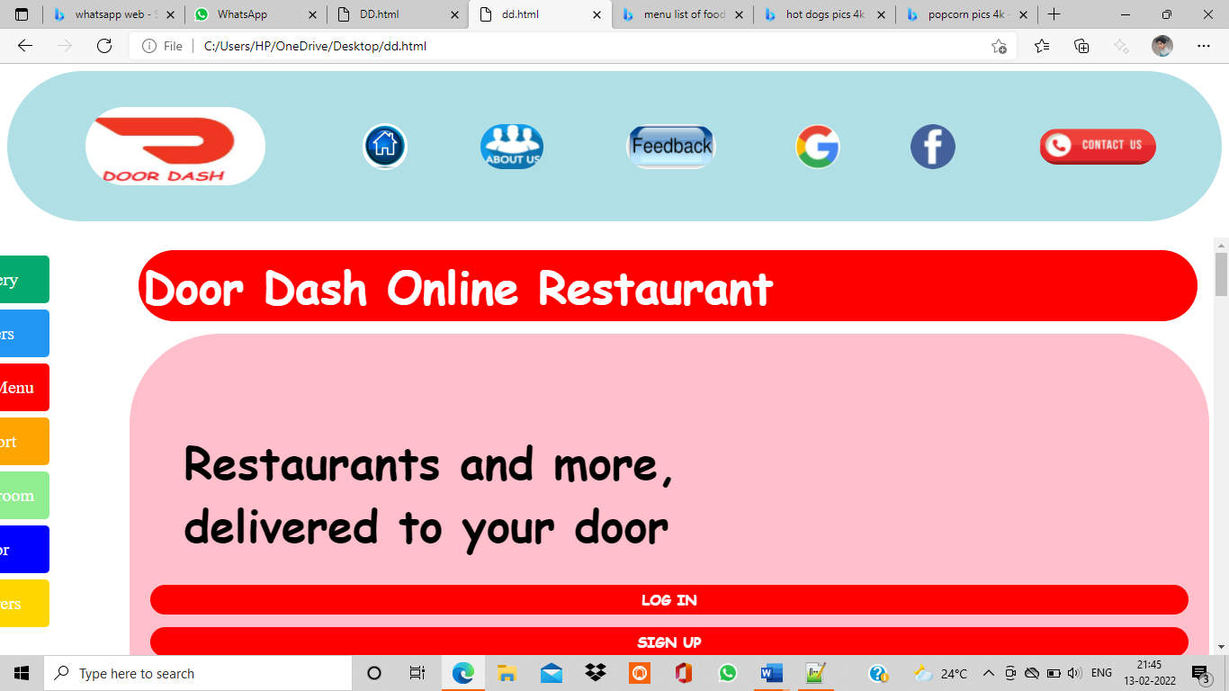

3.Modules:

->The modules that are used in this web application are,

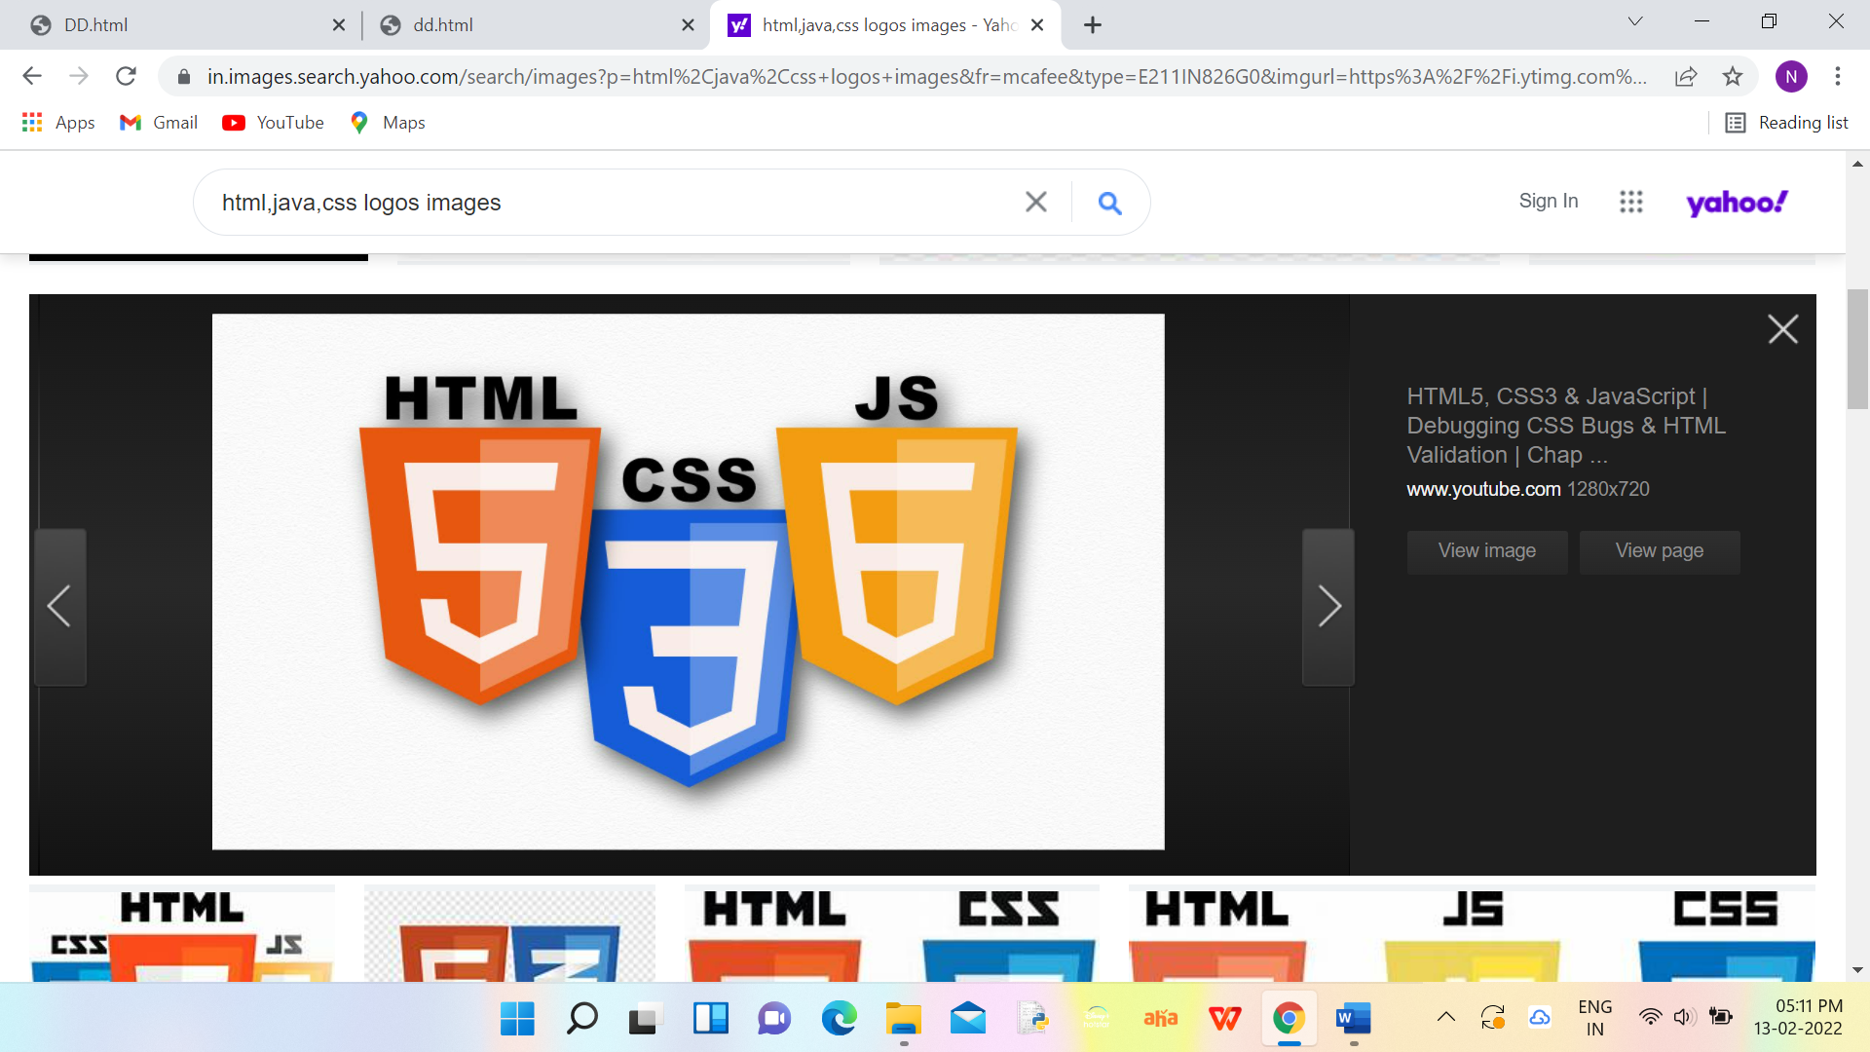

4.Implementation:

Google login Code->

HTML CODE:

<html>

<head>

<link rel="stylesheet" type="text/css" href="1.css">

<link rel="stylesheet" type="text/css" href="button1.css">

<style>

body {

background-image:"google4.jpg";

background-repeat:no-repeat;

background-attachment:fixed;

background-size:cover;

}

a{

text-decoration:none;

}

</style>

</head>

<body background="google4.jpg">

<table align="center" width="40%" height="90%" cellpadding="10" cellspacing="0" bgcolor="lightyellow" class="btnn" >

<th>

<table align="center" width="5%" height="10%" border="0px" cellpadding="5" cellspacing="0">

<th align="top" colspan="6" >

<td><h1 style="color:DodgerBlue;font-family:comic sans ms">G</h1></td>

<td><h1 style="color:red;font-family:comic sans ms">o</h1> </td>

<td><h1 style="color:yellow;font-family:comic sans ms">o</h1></td>

<td><h1 style="color:DodgerBlue;font-family:comic sans ms">g</h1></td>

<td><h1 style="color:MediumSeaGreen;font-family:comic sans ms">l</h1></td>

<td><h1 style="color:red;font-family:comic sans ms">e</h1></td>

</th>

</table>

<table align="center" width="40%" height="70%" border="0px" cellpadding="20" cellspacing="0">

<th><h3 style="color:DodgerBlue;font-family:comic sans ms">Sign In</h3>

<form action="" onsubmit="return myval()" name="gform"> <label for="fname"><p style="font-family:comic sans ms">With Your Google Account</p></label><br><br><br>

<input type="text" id="fname" name="email" placeholder="Email or phone"><br><br>

<label for="lname"><p style="font-family:comic sans ms">Password </p></label><br><br>

<input type="password" id="lname" name="pwd" placeholder="Password"><br><br>

<input type="submit" class="btn1" placeholder="Log in">

</form>

</th> </table> </th> </table> </body> </html>

JAVA SCRIPT CODE:

<script>

function myval()

{

var uname=document.gform.email.value;

var pass=document.gform.pwd.value;

if(uname=="")

{

window.alert("Please enter Email or Phone Number");

document.gform.email.focus();

return false;

}

if(pass=="")

{

window.alert("Please enter Your Password");

document.gform.pwd.focus();

return false;

}

window.alert("Log in Sucessfull");

return true;

}

</script>

NAVGIGATION BAR CODE->

HTML CODE:

<html>

<head>

<link rel="stylesheet" type="text/css" href="button.css">

<meta name="viewport" content="width=device-width, initial-scale=1">

</head>

<body><div id="mySidenav" class="sidenav">

<a href="delivery.html" id="Delivery" target="main">&nbsp;&nbsp;&nbsp;Delivery</a>

<a href="offer.html" id="Offers" target="main"> &nbsp;&nbsp;&nbsp;&nbsp;&nbsp;&nbsp;Offers</a>

<a href="Menu.html" id="Menu" target="main">&nbsp;&nbsp;Food Menu</a>

<a href="support.html" id="Support" target="main">&nbsp;&nbsp;&nbsp;&nbspSupport</a>

<a href="Newsroom.html" id="Newsroom" target="main">&nbsp;&nbsp;&nbspNewsroom</a>

<a href="Interior.html" id="Interior" target="main">&nbsp;&nbsp;&nbsp;Interior</a>

<a href="carrers.html" id="Carrers" target="main"> &nbsp;&nbsp;&nbsp;&nbsp;&nbsp;&nbsp;Carrers</a>

</div>

<div style="margin-left:80px;">

<h2></h2> <p></p> </div>

<table> <tr> <h1 </h1><th> <tr><h1><h1><th> <tr><h1><h1><th>

<tr><h1><h1><th> </table>

</body></html>

JAVA SCRIPT CODE:

<style>

#mySidenav a {

position: absolute;

left: -80px;

transition: 0.3s;

padding: 15px;

width: 105;

text-decoration: none;

font-size: 20px;

color: white;

border-radius: 0 5px 5px 0;

}

#mySidenav a:hover {

left: 0;

}

#Delivery {

top: 20px;

background-color: #04AA6D;

}

#Offers{

top: 80px;

background-color: #2196F3;

}

#Menu{

top: 140px;

background-color:red;

}

#Support {

top: 200px;

background-color: orange;

}

#Newsroom {

top:260px;

background-color:lightgreen ;

}

#Interior{

top:320px;

background-color: blue;

}

#Carrers

{

top:380px;

background-color:gold;

}

</style>

5.Screens:

5.1.Home Page:

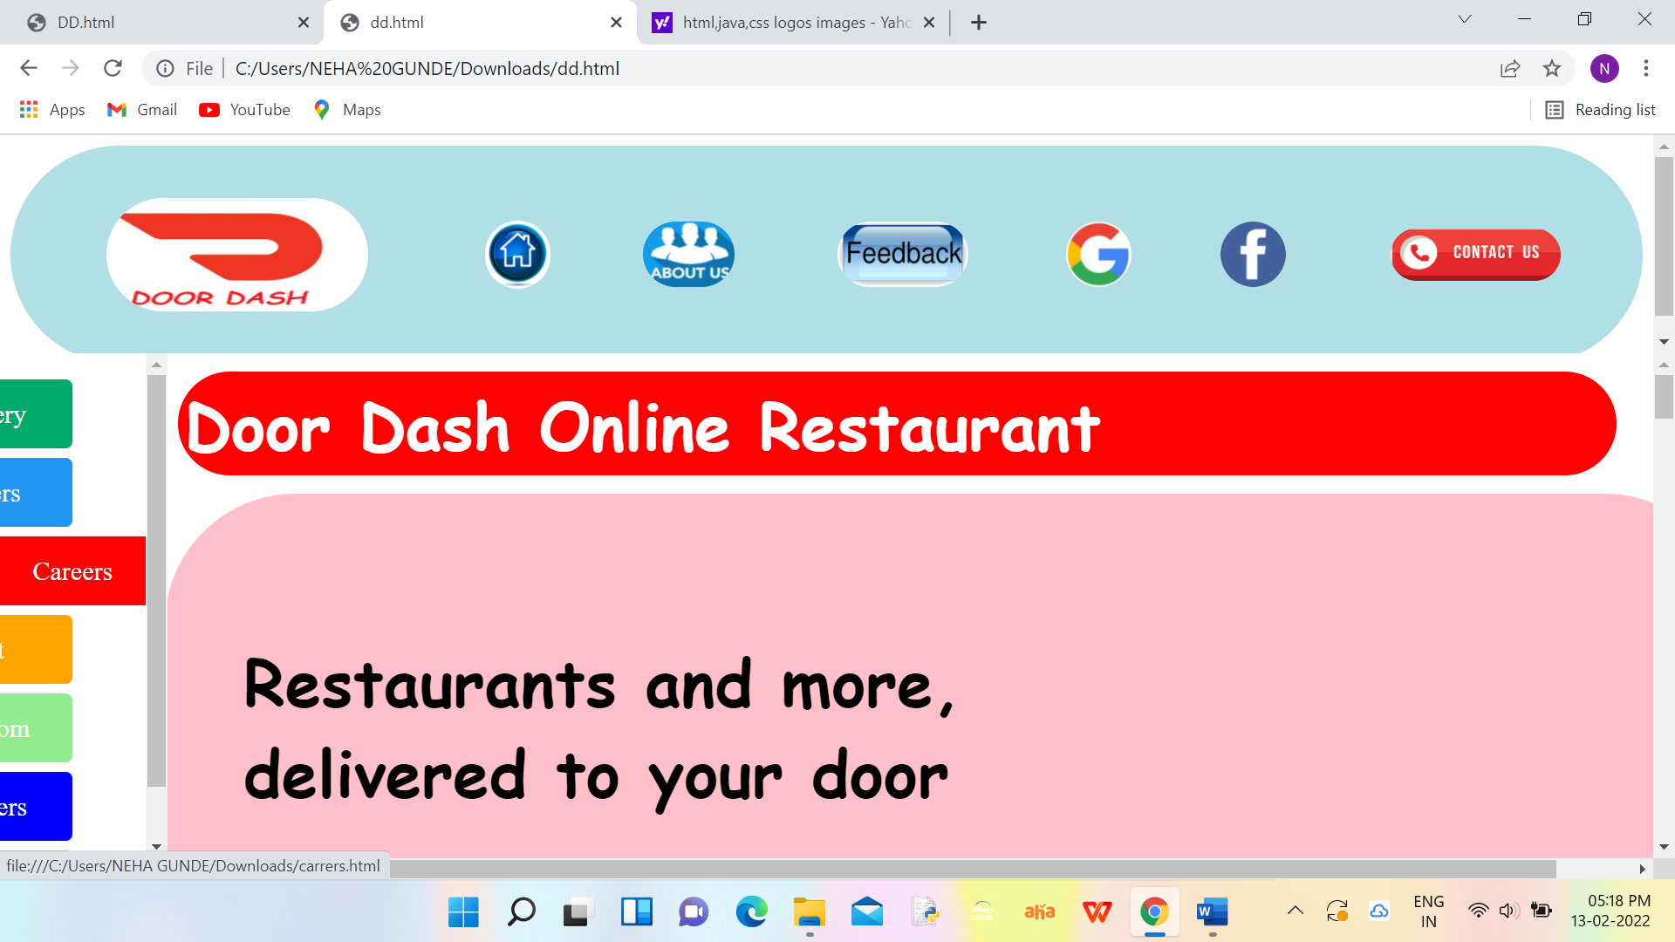 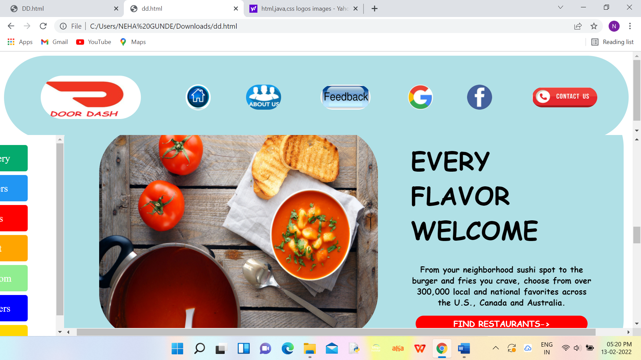

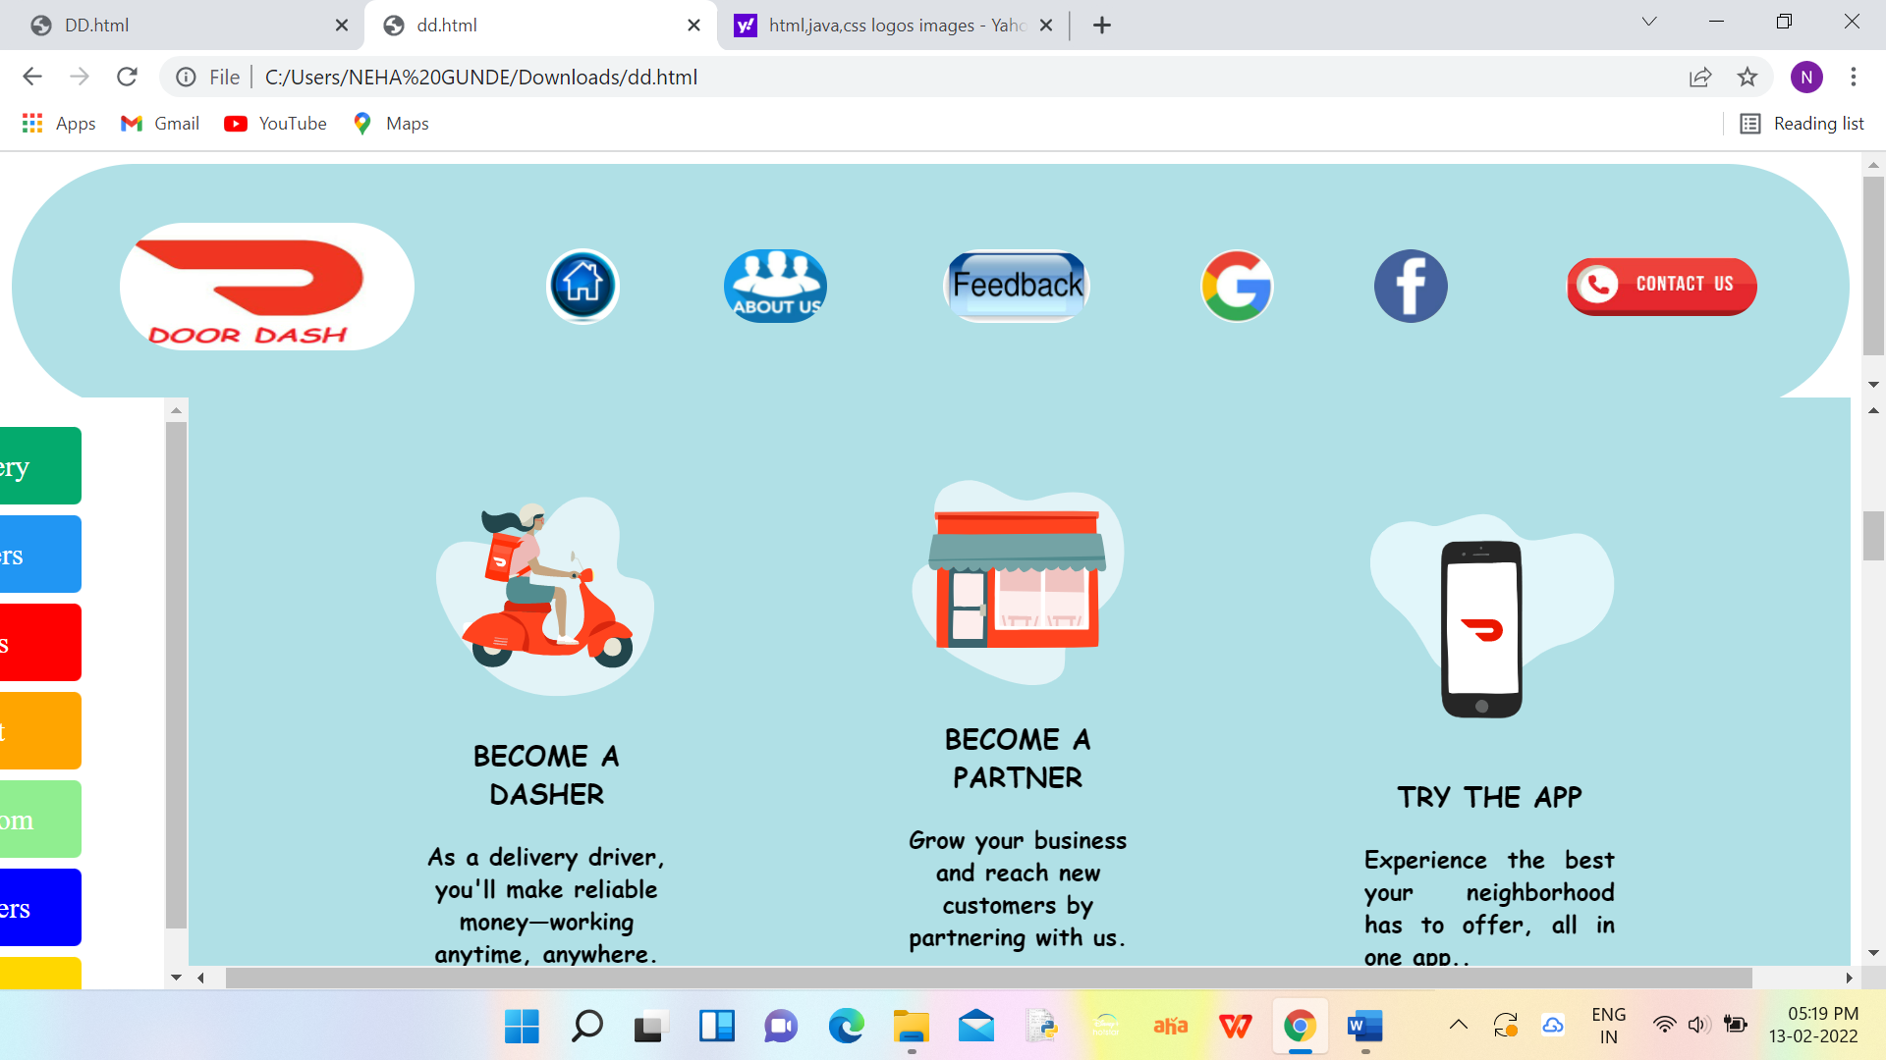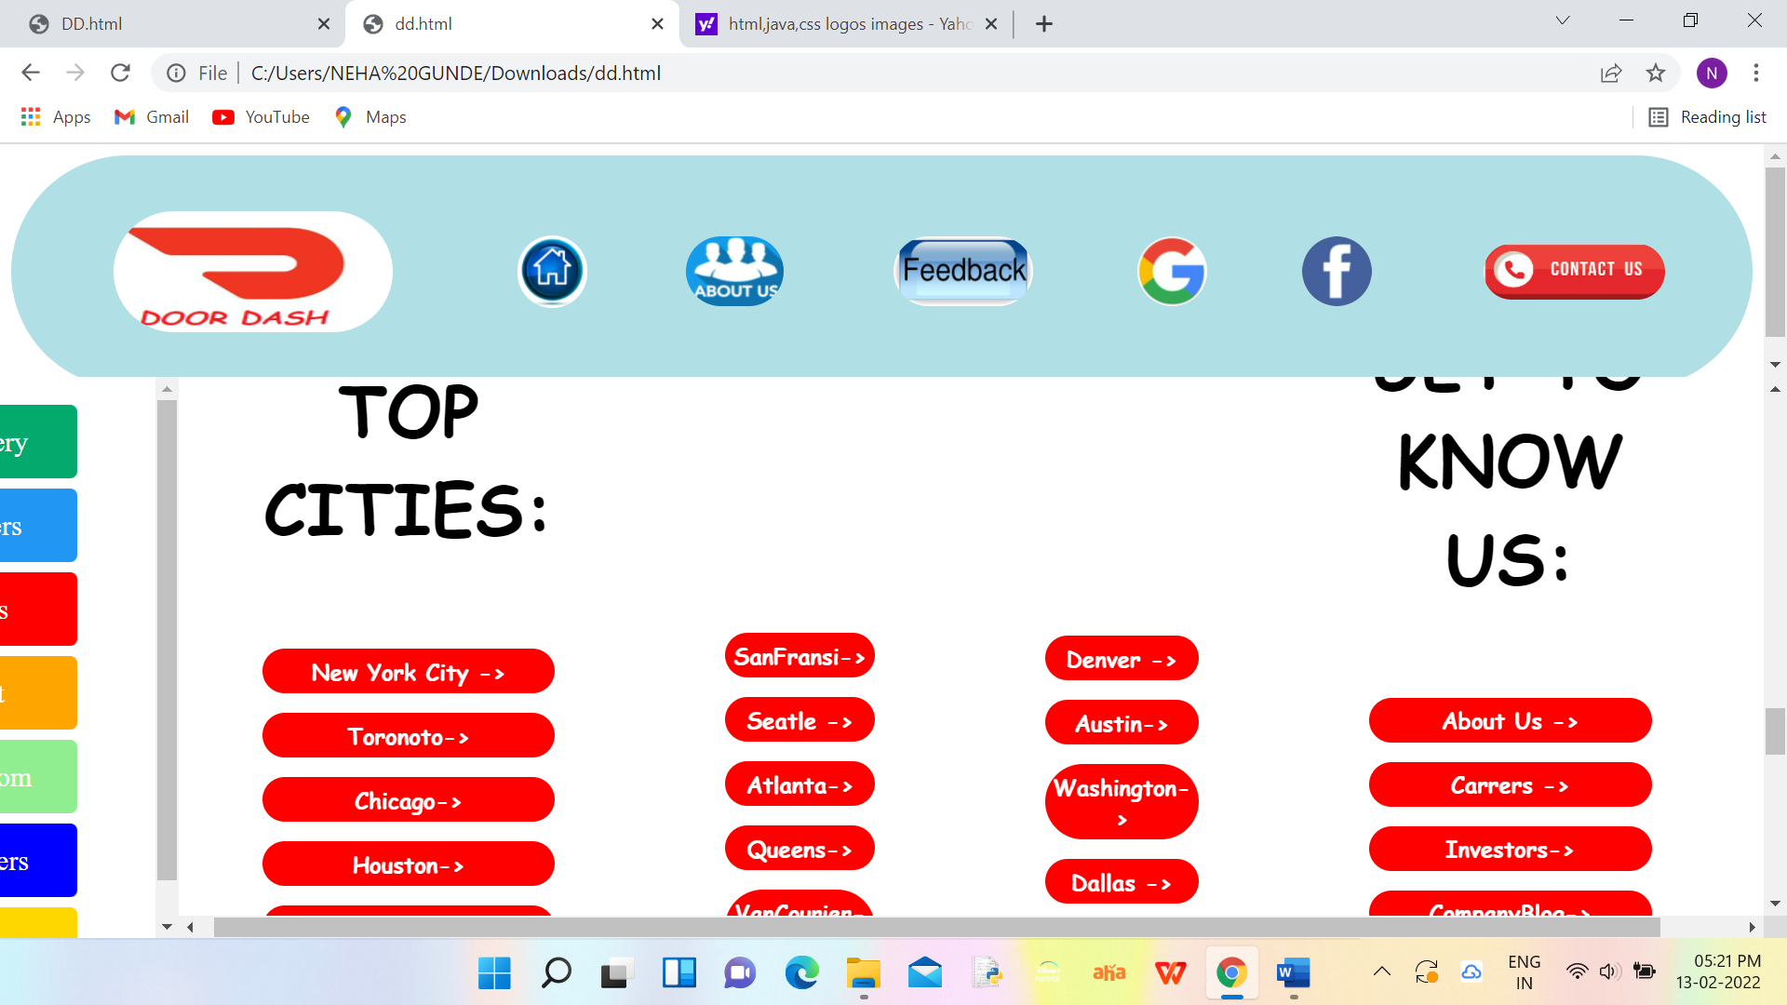

5.2. Sign in Page:

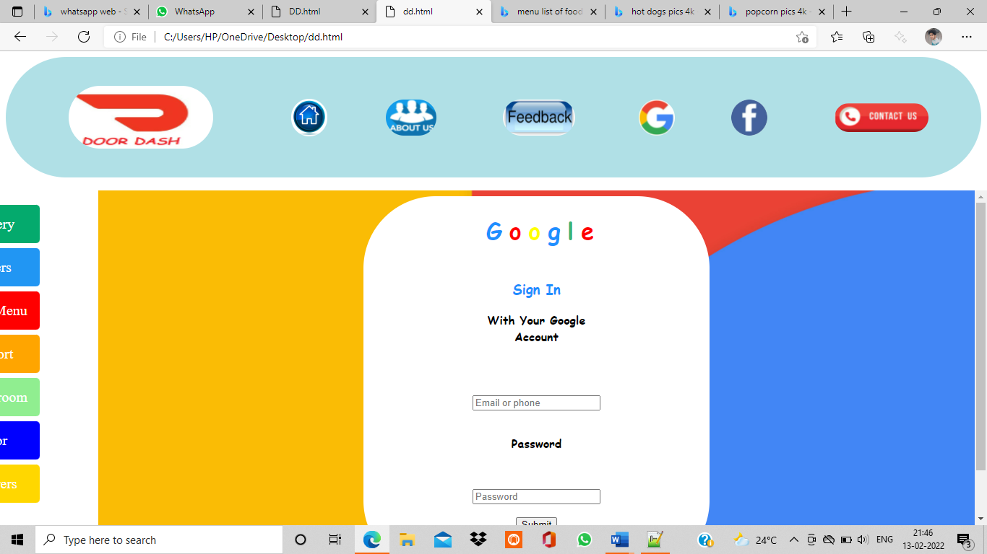

5.3. Menu Page:

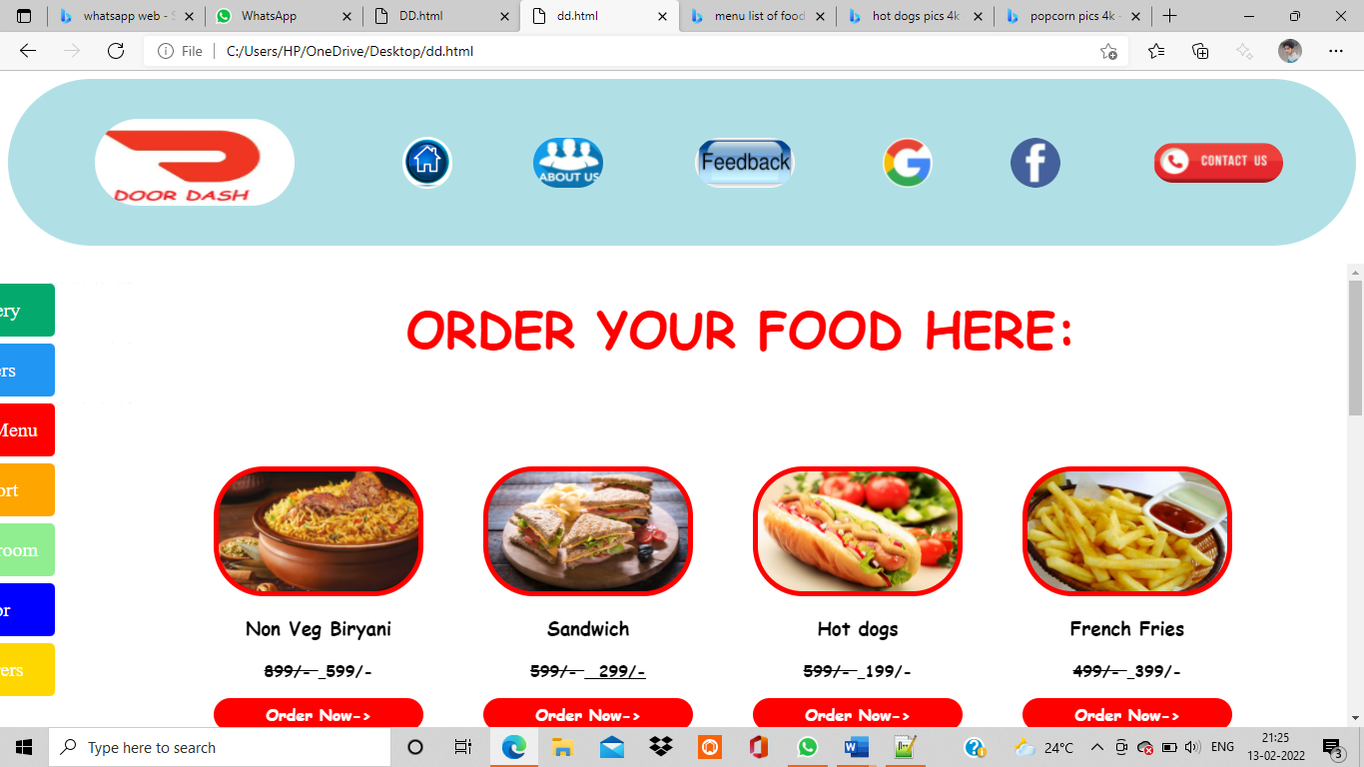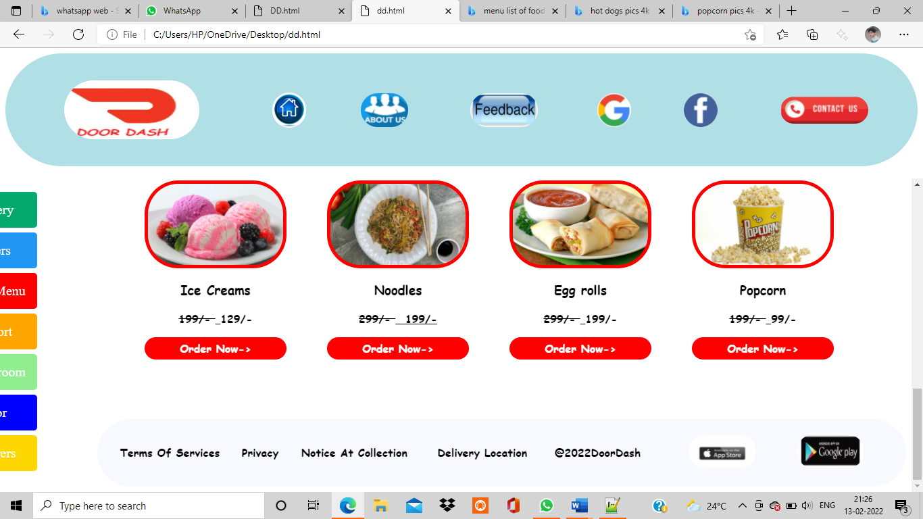

5.4. Feedback page:

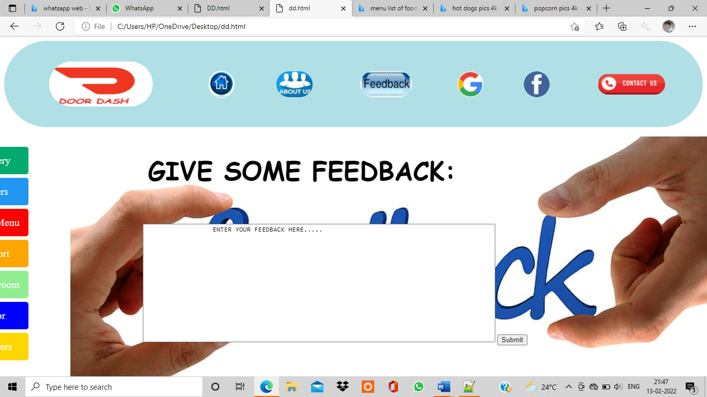6.Conclusion:

->So atlast the main theme of the application is setting up an Online Ordering system which sets up a restaurant for efficiency, growth and a steady increase in revenue.

->If you were new to this online ordering,This is the good way to encourage customers to order on the site…

7.References:

https://www.w3schools.com/howto/howto_css_contact_form.asp

https://www.geeksforgeeks.org/html-geolocation/

https://www.w3schools.com/howto/howto_css_contact_form.asp

https://www.geeksforgeeks.org/html-geolocation/